1. Display the Highest, Lowest, Total & Average salary of all staff. Label the columns Maximum, Minimum, Total and Average respectively for each Department code. Also round the result to the nearest whole number.

Query:

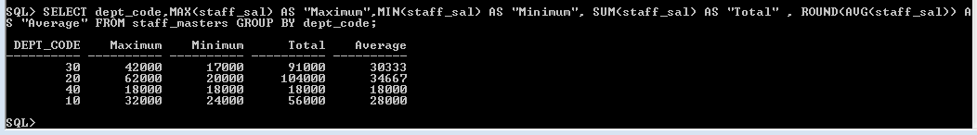

1. Display Department code and number of managers working in that department. Label the column as ‘Total Number of Managers’ for each department.

Query:

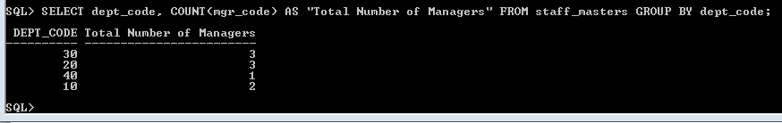

1. Get the Department number, and sum of Salary of all non-managers where the sum is greater than 20000.

Query:

